GPS for special SK7

if the gyro is not installed, and if the Aux connector is removed, then it may be possible to fit this GPS module in the existimg enclosure –

http://www.sparkfun.com/datasheets/GPS/Modules/LS20030~3_datasheet_v1.0.pdf

LS20033

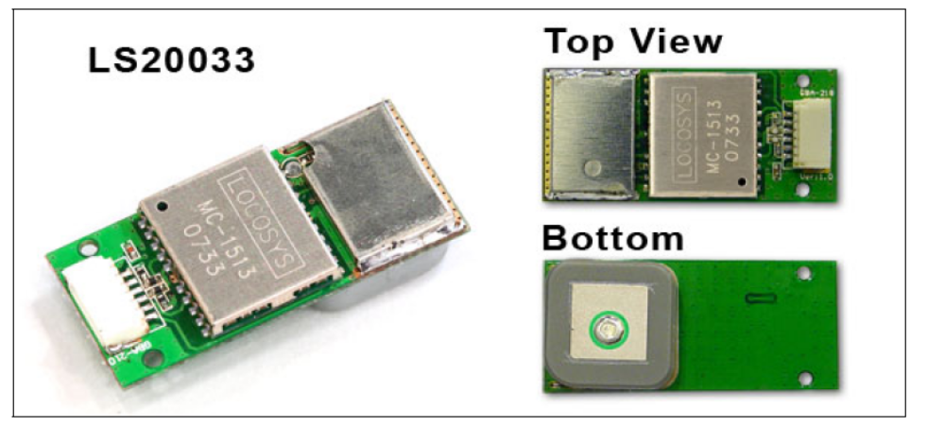

The full length can be reduced if the connector is removed and the PCB is cut. It should be possible to get the size down to 30mm long.

Then the module could rest on top of where the gyro yaw PCB normall sits. Excluding the connector, the total heigth of the module is –

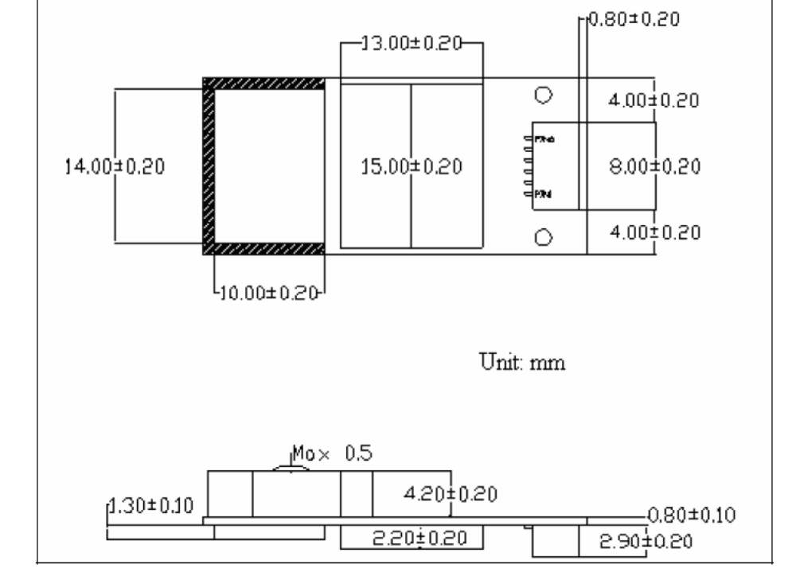

2.2 + 0.8 + 4.2 + 0.5 = 7.7mm

hopefully the area on the under side that is 2.2mm high can go on top of an area of the main PCB that has components of only 1mm heigth.

What is the performance of this module

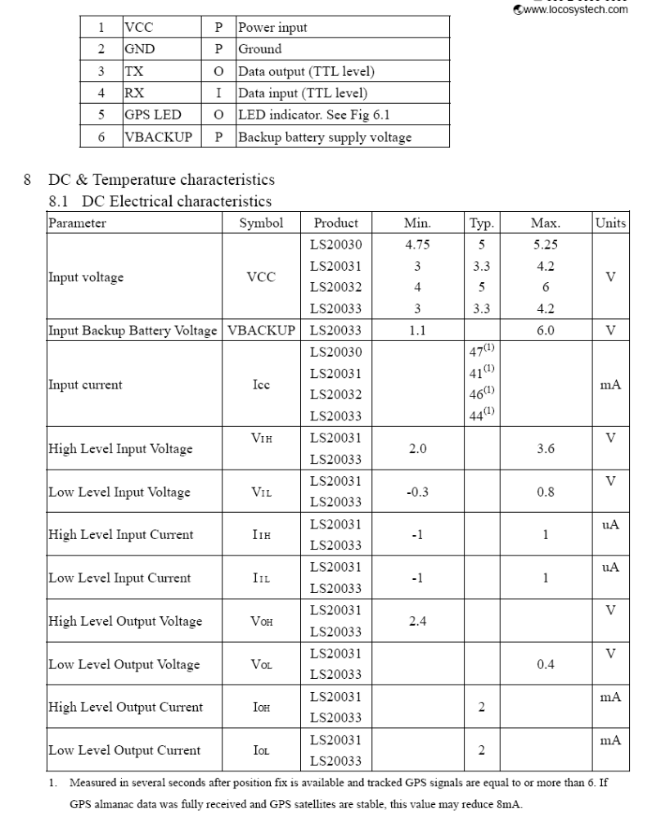

http://diydrones.com/profiles/blogs/705844:BlogPost:49310

Comment by Dean on October 29, 2008 at 3:17am
So... get the LS60033 and poof like magic you have what looks like LS20033 with the ceramic patch wanted by Jhon but Atmel chipset inside. Also, for those that want same form factor, Locosystech even makes SirfStarIII chipset GPS in their LS2002 series: http://www.locosystech.com/product.php?zln=en&id=4
Locosys does not = Mediatek by default.
I have EXTENSIVE testing of the 5Hz MediaTek LS20033 and LS20031 in AttoPilot... The larger LS20031 outperforms the smaller antenna version (LS20033) hands down in controlled experiments for solidity of GPS lock and retention of lock in steep banking turns (45+ degrees)... you only add 7 grams going from LS20033 (9g) to the LS20031 (16g). Key for both Media Tek units (and the ETek version) is smoothest possible power filtering to the GPS.. it is a serious requirement. Give this unit its own voltage regulator, and appropriate filter caps, and maybe even a ferrite toroid to wrap the GPS cable around 4x times.

